**Exercise 2: Error Handling**

Scenario 1: Handle exceptions during fund transfers between accounts.

**PL/SQL Code:**

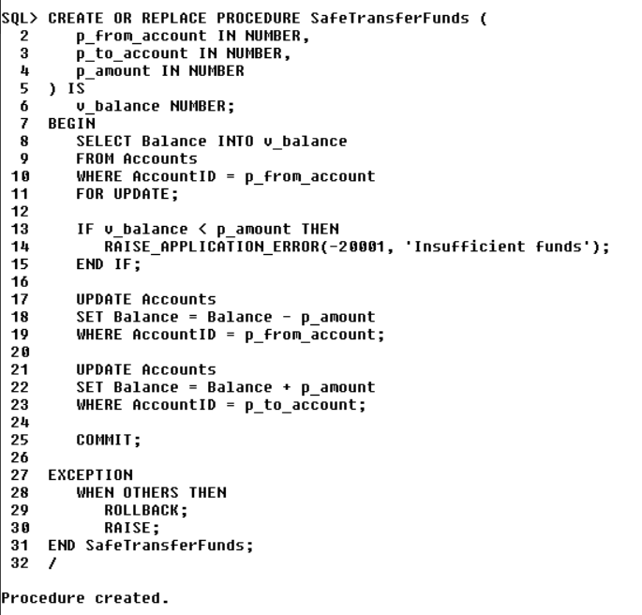

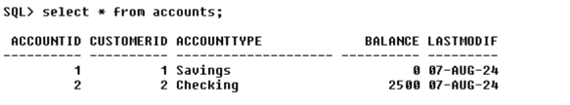

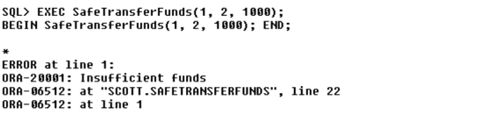

Scenario 2: Manage errors when updating employee salaries.

**PL/SQL Code:**

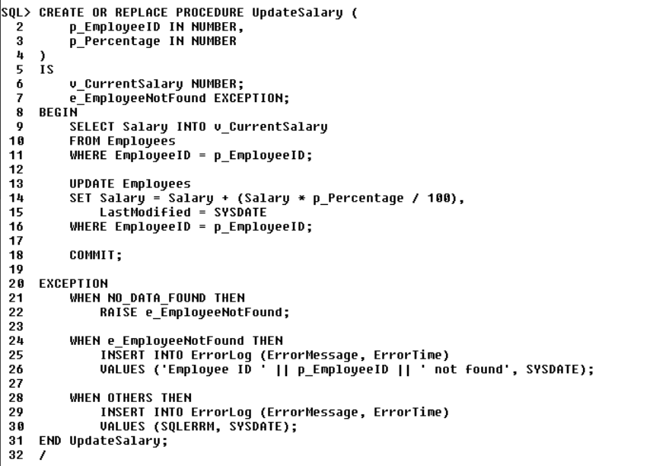

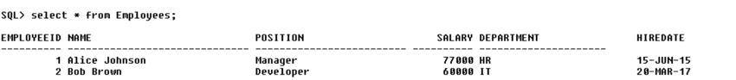

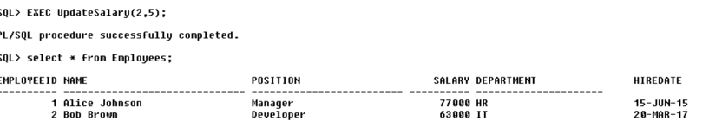

Scenario 3: Ensure data integrity when adding a new customer.

**PL/SQL Code:**



